COM S/SE 319 : Software Construction and User Interfaces Spring 2019

HW 2

Preamble and how to run my HW

This homework is using simple js canvas functions and a for the second tast it uses one library called ‘inquirer’ that helps with obtaining the standard I/O from the user. The paths between files are hard coded so the only requirement is to have all the files on the same level. The files used are named
- Snake.js
- Snake,css
- Snake.html
- Hw3.js
It has a small CSS file to make it look decent.

1. Task 1 – Snake game
The snake is pretty simple on the view side, it starts the canvas and the three buttons. One to start the timer and two others to switch it around. Inside the JS file, there is a function that triggers the timer when the start button is pushed. This timer function can also be stopped by hittinh the start button (which changes to stop when it is triggered) which will cancel the timer. This timer’s job is to call a move function every span of time to give it the sense that the line is moving. The move function is calculated to move the canvas cursor at a fixed distance and stroke a line at that point.
The direction of the line is adjusted by two switch functions that allow the user to turn right or left accordingly. The functions changes the increments or decrements to the X and Y coordinates that the move function applies.
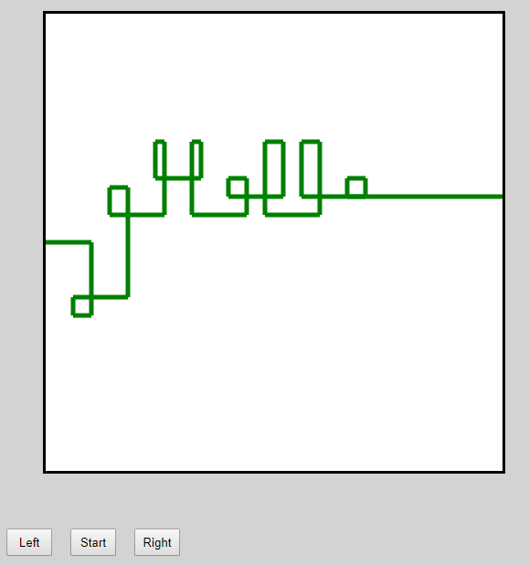

2. Node.JS Input Handling

The next task pertains the usage of node.js to write a simple I/O program that does several easy tasks. For this I used a library in node.js called inquirer which works simply. It allows you to initialize an array with question objects with certain parameters. These include the name if the answer, type if value expected and a validation function to check if the input is valid. I made an array with 4 question objects asking for numbers and passed them to the inquirer.
After running it will return me an “answers” object with all 4 numbers that my user will have filled out. When this is ready, I only have to parse and modify these number answers to do the small tasks asked for.
- I run the first number as an index in a loop and multiply iteratively the sequence of its numbers to get its factorial
- Next number I treat like an array of chars and using a loop I obtain each digit and cast it as a number after adding them to a adding int that stores the collective sum of all of them
- The third number I treat as a String and simply access its members like I would a char array. I do a backwards loop and add the results to a final string to print.
- Lastly the fourth is a loop that only iterates through half of the number. I again treat it like a String and check in the same loop the end and the front against each other until they meet in the middle, if the loop ends without any mismatches then it is a palindrome.

